Rosanna Cubs
– Swimming night
WaterMarc Greensborough
Tuesday 27th March, 6:45pm-8:30pm

This week, we’ll be going swimming (and sliding) at WaterMarc in Greensborough. This will be a fun night rather than a badge night – Cubs will have a swimming night later in the year for Swimming Badges.

- 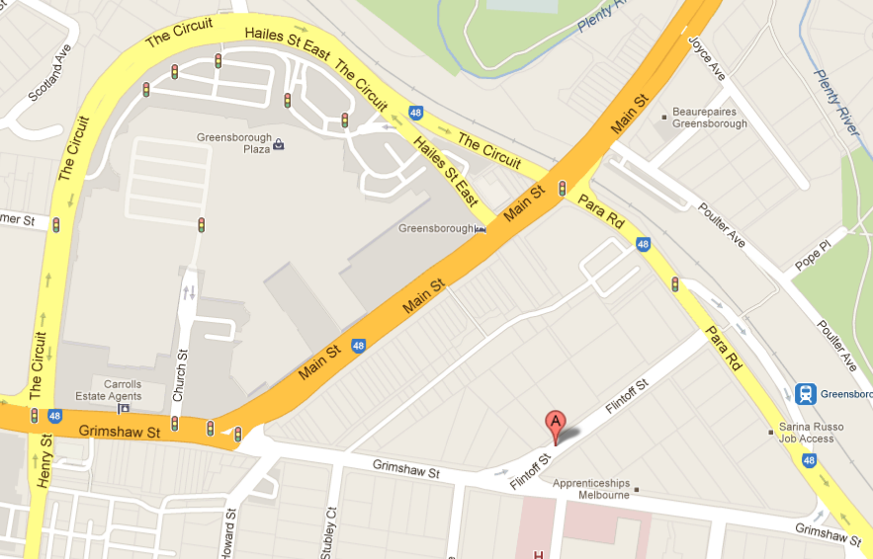Time: 6:45-8:30pm – Note different time
to normal Cubs. Pool is open to
9:30pm for families who choose to
stay on.
- Cost: Cubs:
  - Swim & Waterslides $12.60
  - Slides Only, if you already have swim membership $6.80
  - Swim only $5.80
Family:
  - Swim & Waterslide $12.80
  - Slides Only, if you already have swim membership $7.00
  - Swim only $5.80
  - Entry only $3

- There are height rules for the Waterslides (slides open until 8:00pm)
  - Taller than 122cm = can go on all slides
  - 107cm<122cm = can go on Pipeline
  - Shorter than 107cm = can’t go on waterslides
…..To save time, please know your Cub(s)’ height

- Location: WaterMarc Aquatic Centre –
1 Flintoff St, Greensborough
- Bring: Togs, Towel, money for your entry, & warm clothes to go home in, plus swim googles, snacks/drink bottle if you want them.

Don’t miss out – see you there!

Regards

The Leaders
Rosanna Cub Scouts

See Rosanna Cubs at http://www.rosannacubs.org

